Our Stories – God’s Story
Lesson 4

Name Games
Name toss
You will toss a ball around the circle using names to signal each other. The variations in each round will change the game slightly but the general idea stays the same.

Supplies: ball to toss

Round 1: Normal Name Toss
- Arrange the group in a circle. Have everyone introduce themselves to the people on their left and right. If you need to go around the circle and have everyone say their name out loud to the group too.
- Have everyone hold their hands out front of them to start. Instruct them to put their hands behind their back once they receive and toss the ball to someone else. This will make sure everyone gets the ball.
- One person starts off by saying the name of someone else in the circle and tossing the ball to them.
- That person then in turn says the name of a different person, and tosses the ball to
someone else who has not yet received the ball.
- That continues until everyone in the circle has received the ball once.
- When everyone has received the ball start the pattern again. Throwing to the SAME person you threw the ball to the first time. (you can do this a couple times to make people comfortable before missing it up again)
Round 2: Reverse
For this round try the pattern in reverse. Throwing the ball to the person who threw you the ball (still make them name names before throwing to that person)
Round 3: Mix up
Have everyone pick a new spot in the circle. Not standing by the same people. Have them introduce themselves to the left and right. Then try to do the original pattern from round one in the new spots.

Blanket Name Game

Supplies: Large blanket (king or bigger)
Two chairs

Place the two chairs facing one another. You will be holding the blanket between the chairs so the two people sitting in the chairs can’t see one another.

- Separate into two groups
- Have two people hold a large, thick blanket separating the two groups so that neither group can see the other.
- Each group will send one person to sit in the chair.
- When the people are seated, the blanket drops and the first person to correctly call out the name of the other group’s designated person wins the round
- The winner wins that person t their team (loser joins winning team)
- Repeat as many times as you want.

Demo Game

Supplies: Tape for floor
Grid map for leader

Create a grid of 4 X 5 “X”’s on the floor with tape. (Do not put the arrows down). Each student will have a turn to try and find their way through the grid. They will not have a map.

Open by telling the students there is only one right way to get across this grid. You can move to any a joining X, yes even diagonally. Every X is only used once. Each of them will have a turn to try and find the path, but the minute you pick a wrong X they are out. We will cycle through the line as many times as we need to find the right path. Students are allowed to help one another.

- Have the first student start by trying to find the “entrance” the first X that begins the path. The leader will be the only person with the map. If the student guesses wrong the leader will say “Sorry, NO” or make a buzzer sound to let them know they are wrong.
- When they pick a wrong X they are out and go to the end of the line of students.
- Students keep trying, until someone makes it all the way through according to the secret map the leader is following.

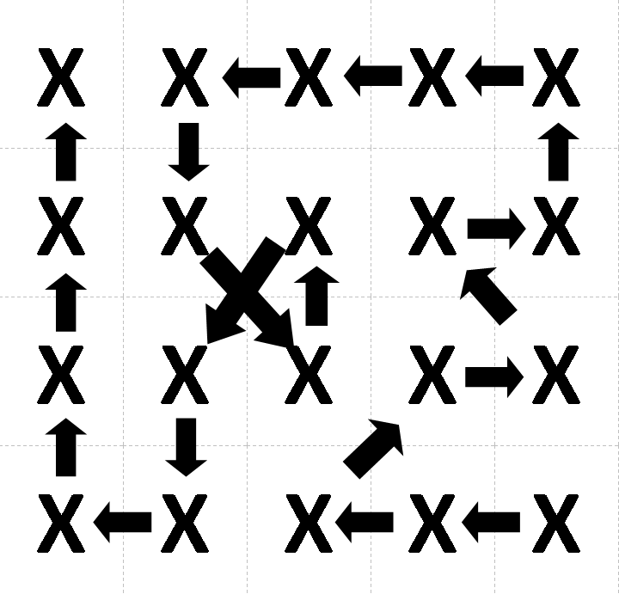
Lesson
What did you learn/feel reading the fall story?
Why is it important for this story to be in the Bible?

What is sin? Target demonstration
What does sin do to out relationship with God? Tissue and cup demo
What does it do to our human relationships? Person to person demo

Your description of original sin.
Voices that call us to sin (inside and out)

What happens when we ignore the separations sin creates?
Why is it hard for us to fess up to our brokenness?
Why is it good to notice where we are weak and when we have been tempted?

This is all personal sin, what about sins you see in the world?
How do you see sin effecting your life? Sinned against/sinning

What did you think about the trail metaphor?
Trail markers
Switch backs
Short cuts

Thoughts about suffering
God’s heart breaking
Good God allow suffering?

Voicing calling us back
Prophets
Jesus
In your life?

Confession
Psalm 51

Remaining questions

Antsy Game

Plate Drawings

Supplies: Paper plates for everyone (multiple of you want more options)

- Hand out a paper plate to everyone
- Have them hold the paper plates above their head
- While the plate is on top of their head have them draw a simple image (a house, their bedroom, a dog, etc. )
- Share the pictures with one another.

